Rakshith Churchagundi Amarnath

A20424771

CSP 554 Assignment 3

6) Output of WordCount2.py

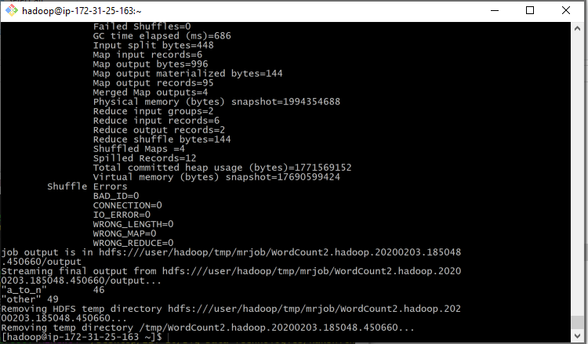

10) Output of Salaries2.py

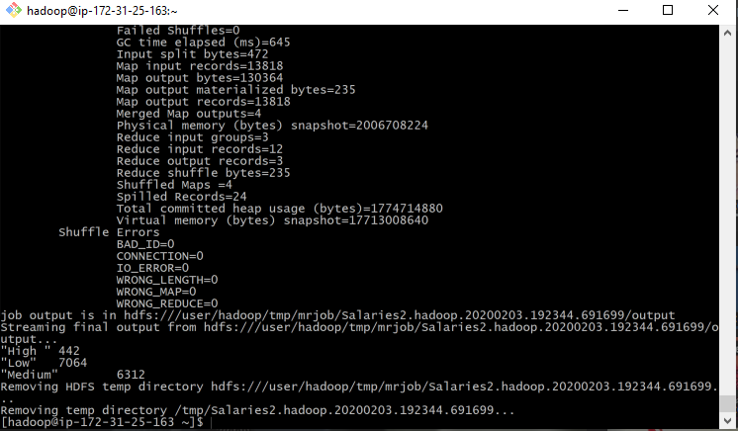

12) Output of Movies.py

